**[Sum of Distances in Tree](https://leetcode.com/problems/sum-of-distances-in-tree/description/)**

There is an undirected connected tree with n nodes labeled from 0 to n - 1 and n - 1 edges.

You are given the integer n and the array edges where edges[i] = [ai, bi] indicates that there is an edge between nodes ai and bi in the tree.

Return an array answer of length n where answer[i] is the sum of the distances between the ith node in the tree and all other nodes.

Example 1:

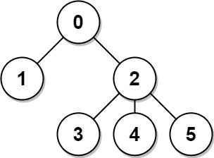

Input: n = 6, edges = [[0,1],[0,2],[2,3],[2,4],[2,5]]

Output: [8,12,6,10,10,10]

Explanation: The tree is shown above.

We can see that dist(0,1) + dist(0,2) + dist(0,3) + dist(0,4) + dist(0,5)

equals 1 + 1 + 2 + 2 + 2 = 8.

Hence, answer[0] = 8, and so on.

Example 2:



Input: n = 1, edges = []

Output: [0]

Example 3:

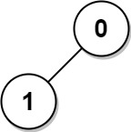

Input: n = 2, edges = [[1,0]]

Output: [1,1]

Constraints:

* 1 <= n <= 3 * 104
* edges.length == n - 1
* edges[i].length == 2
* 0 <= ai, bi < n
* ai != bi
* The given input represents a valid tree.